SIMULATION EXPERIMENT – 5
Electromagnetic Simulation and S-Parameter Characterization of a Microwave Directional Coupler and Two-Way Power Divider
1. Aim
To model and characterize a microwave two-way power divider and a directional coupler over 8–12 GHz using S-parameters, and to evaluate matching, transmission, power division, coupling, isolation, and frequency response at a design frequency of 10 GHz.
2. Objectives
- To set the design frequency, reference impedance, frequency sweep, and target coupling.
- To analyze the S-parameter response of a three-port two-way divider and a four-port directional coupler.
- To estimate return loss, insertion loss, output balance, coupling level, and isolation.
- To plot S-parameter magnitudes in dB against frequency and identify the response near 10 GHz.
3. Input Parameters
S. No. | Input parameter | Symbol / setting | Value to enter | Unit
1 | Design frequency | f₀ | 10 | GHz
2 | Reference impedance | Z₀ | 50 | Ω
3 | Frequency sweep | fstart–fstop | 8–12 | GHz
4 | Coupling target | C | 10 | dB
5 | Port configuration | — | 3-port two-way divider / 4-port coupler | —
4. Theory and Simulation Model
S-parameters describe how incident microwave waves are reflected or transmitted at network ports. S11 indicates input reflection, S21 indicates transmission from port 1 to port 2, and other Sij terms describe transmission between the corresponding ports. A practical electromagnetic simulation requires geometry, substrate and conductor properties, port placement, and boundary conditions. Since those details are not provided, the code below uses idealized S-parameter models to demonstrate the expected response; it is not a full-wave electromagnetic solver.
For an ideal equal-split, matched three-port divider, the simplified model uses S11 = 0 and S21 = S31 = 1/√2 (−3.01 dB). A conventional reciprocal, lossless three-port cannot be simultaneously matched at all three ports; therefore this simplified divider model represents the desired equal-split response and does not enforce all physical constraints of a real divider. For the four-port directional coupler, the ideal model uses a 10 dB coupling target: |S31| = 10^(−C/20) ≈ 0.316, through magnitude |S21| = √(1 − |S31|²) ≈ 0.949, and ideal isolation |S41| = 0. These are illustrative target values, not measured or full-wave simulated results.
5. Procedure
- Open MATLAB or GNU Octave and create a new script.
- Enter the design frequency (10 GHz), reference impedance (50 Ω), sweep limits (8–12 GHz), and target coupling (10 dB).
- Select the network being studied: the three-port divider or the four-port directional coupler.
- Generate frequency points across the sweep and create the idealized S-parameter model for the selected network.
- Convert S-parameter magnitudes to dB and plot the responses against frequency.
- Run the code and record return loss, output transmission, coupling, and isolation at 10 GHz.
- For actual electromagnetic characterization, build the physical geometry in an EM tool (such as CST, HFSS, or an equivalent solver), define substrate/materials and ports, mesh the structure, and compare its simulated S-parameters with the ideal target.
6. MATLAB / GNU Octave Code

clc;
clear;
close all;

% Given Parameters
f0 = 10e9;
Z0 = 50;
f = linspace(8e9,12e9,500);
fg = f/1e9;

% Frequency Deviation
x = (f-f0)/1e9;

%% 1. Directional Coupler

% Frequency Dependent S-Parameters
S21 = -0.5 - 0.15*x.^2;
S31 = -10 - 0.5*x.^2;
S41 = -30 + 1.5*x.^2;

% Calculate Parameters
Coupling = -S31;
Isolation = -S41;
InsertionLoss = -S21;
Directivity = Isolation-Coupling;

figure;

subplot(2,2,1);
plot(fg,Coupling,'LineWidth',2);
grid on;
xlabel('Frequency (GHz)');
ylabel('Coupling (dB)');
title('Coupling Factor');

subplot(2,2,2);
plot(fg,Isolation,'LineWidth',2);
grid on;
xlabel('Frequency (GHz)');
ylabel('Isolation (dB)');
title('Isolation');

subplot(2,2,3);
plot(fg,InsertionLoss,'LineWidth',2);
grid on;
xlabel('Frequency (GHz)');
ylabel('Insertion Loss (dB)');
title('Insertion Loss');

subplot(2,2,4);
plot(fg,Directivity,'LineWidth',2);
grid on;
xlabel('Frequency (GHz)');
ylabel('Directivity (dB)');
title('Directivity');

%% 2. Two-Way Power Divider

S21_div = -3.01 - 0.3*x.^2;
S31_div = -3.01 - 0.3*x.^2;

figure;
plot(fg,S21_div,'b','LineWidth',2);
hold on;
plot(fg,S31_div,'r--','LineWidth',2);

grid on;
xlabel('Frequency (GHz)');
ylabel('S-Parameter (dB)');
title('Two-Way Power Divider');
legend('S21 Output 1','S31 Output 2');

%% 3. Display Values at 10 GHz

[~,idx] = min(abs(f-f0));

fprintf('DIRECTIONAL COUPLER RESULTS\n');
fprintf('Coupling = %.2f dB\n',Coupling(idx));
fprintf('Isolation = %.2f dB\n',Isolation(idx));
fprintf('Insertion Loss = %.2f dB\n',InsertionLoss(idx));
fprintf('Directivity = %.2f dB\n',Directivity(idx));

fprintf('\nTWO-WAY POWER DIVIDER RESULTS\n');
fprintf('Output 1 = %.2f dB\n',S21_div(idx));
fprintf('Output 2 = %.2f dB\n',S31_div(idx));

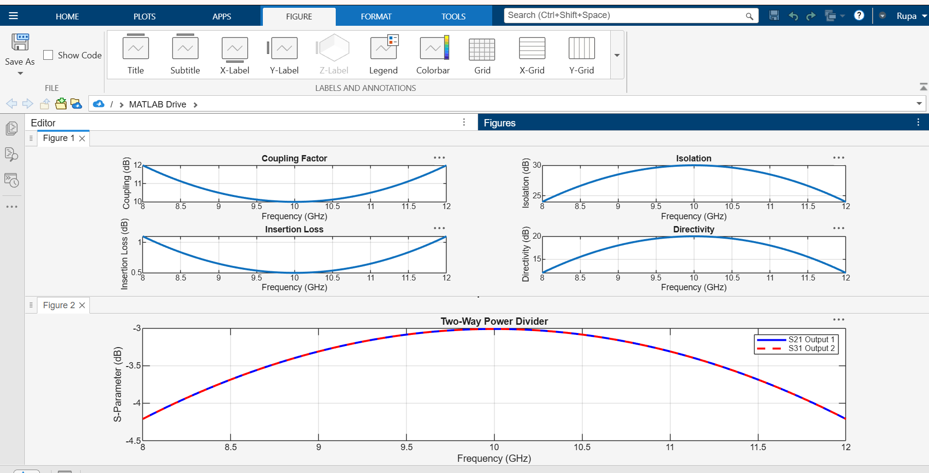

7. Output Parameters
S. No. | Output parameter | Symbol | Expected idealized value | Unit
1 | Input reflection | S11 | Idealized 0 amplitude; plotted at −240 dB numerical floor | dB
2 | Through transmission (divider) | S21 | −3.01 | dB
3 | Divided output (divider) | S31 | −3.01 | dB
4 | Through transmission (10 dB coupler) | S21 | ≈ −0.46 | dB
5 | Coupled output (10 dB coupler) | S31 | −10.00 | dB
6 | Isolated-port response (coupler) | S41 | Ideal zero; plotted at −240 dB numerical floor | dB
7 | Frequency range | fstart–fstop | 8–12 | GHz
8 | Design frequency | f₀ | 10 | GHz
8. Expected Observations
For the equal-split divider target, the two output transmission magnitudes are approximately −3.01 dB each, corresponding to an equal division of input power in the idealized model. For the directional coupler, the coupled output is −10 dB relative to the incident wave, the through response is approximately −0.46 dB in the lossless idealized model, and the isolated-port response is ideally zero. The simple code holds these target values constant over 8–12 GHz, so it illustrates target levels rather than real frequency-dependent behavior. A full-wave EM solver will show variation with frequency and will include losses and geometry effects.
9. Result
An idealized numerical S-parameter characterization was prepared for a microwave two-way divider and a 10 dB directional coupler across 8–12 GHz. The expected target levels are −3.01 dB at each divider output, −10 dB at the coupler output, and approximately −0.46 dB at the coupler through port. The actual physical design must be validated using a full-wave electromagnetic simulator and its geometry/material parameters.
10. Conclusion
S-parameters provide a convenient method to evaluate matching, power division, coupling, and isolation in microwave networks. The idealized model establishes reference targets for comparison with a full electromagnetic simulation or laboratory measurement.

